 **East West University**

**LAB 07**

CSE366(2) – Artificial Intelligence

[Fall 24]

**Lab Report**

**Image Classification with Caltech-101 Dataset**

Submitted by

Md. Sabbir Hossain

2020-2-60-107

Submitted to

Dr. Raihan Ul Islam

Associate Professor

Department of Computer Science and Engineering

East West University

**Introduction:**

This project pursues the goal of image classification using the Caltech-101 dataset where images belong to 101 categories. In this regard, the different featured deep learning approaches, including the traditional CNNs and YOLO (You Only Look Once) for the object detection tasks, are explored. The model uses three architectures from CNN: VGG19, ResNet50, and EfficientNetB0, besides YOLO, for evaluating and comparing their applicability to image classification.

The VGG19 model that is known widely for its simplicity, as well as for being deep, serves as the base benchmark. This model, consisting of nineteen layers, is one of the most used architectures in image classification tasks, and the major downside to it is that it is quite computationally expensive.

Therefore, we also employ ResNet50, which is said to be more advanced in that it has implemented residual connections. This allows deeper networks to be built without the major problem of vanishing gradients often found in normal CNNs. Thus, ResNet50 can be appropriate for more complex endeavors.

In addition to the above, we conduct experiments using EfficientNetB0 that incorporates a compound scaling method to optimize the performance of the model. By balancing the parameters depth, width, and resolution, EfficientNetB0 can attain high accuracy at fewer parameters when compared with traditional architectures of CNNs, rendering it both computationally and effective.

In addition to all those models, we factor in YOLO, which has been touted to be cutting-edge when it comes to detection of real-time objects. It provides a fast and efficient way to identify the objects in an image and finds a lot of applications in field operations that need both accuracy and speed.

Grad-CAM is one of the primary XAI strategies applied in this context to improve interpretability of the model. The way Grad-CAM visualization sheds light on the decision-making of these models is by showing the parts of the image that.

**Objective:**

The main aim of this project is to build, train, and evaluate several deep learning models using the Caltech-101 dataset for image classification, containing images from 101 different categories. In this regard, we consider three state-of-the-art CNNs: VGG19, ResNet50, and EfficientNetB0. Each model represents another approach to deep learning: VGG19 has a simple and effective architecture; ResNet50 uses residual connections to allow much deeper models; and EfficientNetB0 offers a better balance of model efficiency with accuracy.

Besides traditional CNN architectures, we also apply the YOLO model for real-time object detection. It shows that it is capable of fast and precise localization of objects in an image.

We further enhance the transparency and interpretability of these models by incorporating Explainable AI techniques, more specifically Grad-CAM. Grad-CAM helps to highlight regions of an image that are influencing model predictions, thus facilitating the interpretation and explainability of models' decision-making processes. This combination of deep learning models with XAI techniques enables both high performance in the results and further insight into the inner workings of models.

**Training and validation accuracy/loss:**

The model was trained for 10 epochs. During training, the training accuracy increased with a steady rise, showing that at each step, the model learned to classify images more and more accurately. Correspondingly, the training loss decreased over time, which means that the model fitted better to the training data while minimizing the error between its predictions and the true labels.

The validation accuracy followed the same trend as the training accuracy, with some plateauing after 10 epochs. This might be because the model has reached its capacity to generalize on the validation data and it showed signs of not improving further. The loss of validation also showed a similar trend. It decreased initially and, however, sometimes had small oscillations that could be due to the overfitting of the model or variances in the validation data. Such oscillations mean that while the model learned, its generalization to the validation set was not perfect after some number of epochs.

**Insights:**

It would appear that the model generalizes well, as can be seen by the increasing validation accuracy over time. That is to say, although different images were present in the validation set, the model was able to learn generalizable patterns from the data.

Overfitting was observed since the training accuracy increased faster than the validation accuracy in the later epochs. This is a sign that the model began to memorize the training data, which would decrease its ability to generalize well on new data.

Early stopping or dropout are some regularization techniques that one can try in further training to avoid overfitting. Early stopping will stop the training process when it sees that the validation loss is not improving anymore, while dropout prohibits the model from over-relying on specific features during training.

**Plot:**

Below are the **training and validation accuracy/loss curves** that visually represent the model's performance throughout the training process. These plots help illustrate the trend of improvement in accuracy as well as the reduction in loss, which are key indicators of model performance over time.

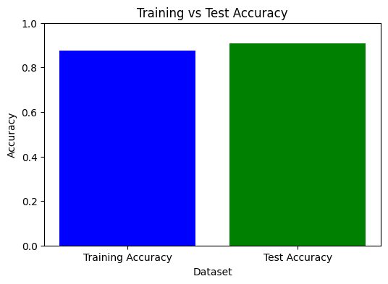

**Figure1:** Training and Testing accuracy

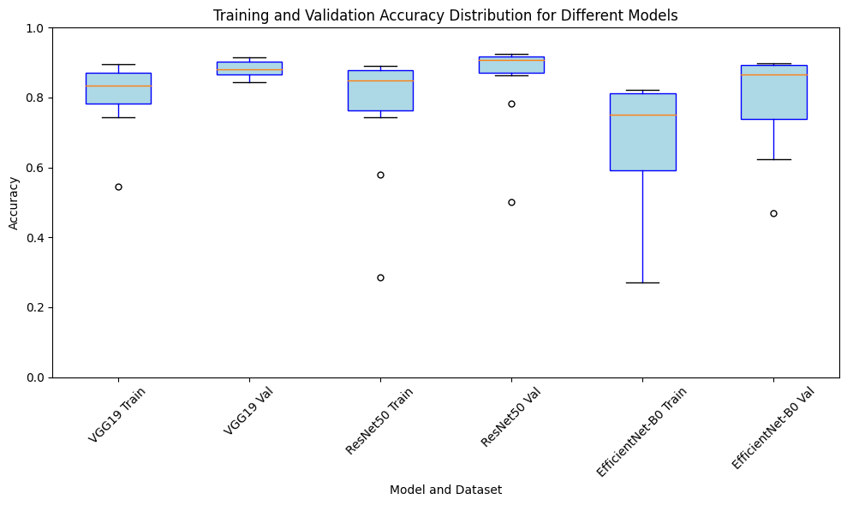

**Figure2:** Boxplot for every model trained for dataset

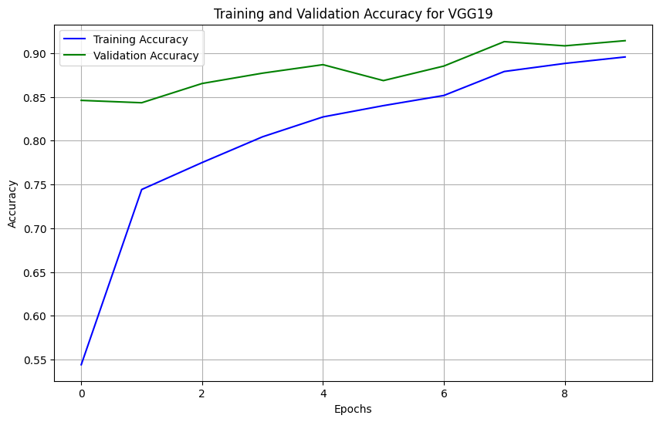

**Figure3:** Training and Validation accuracy for VGG19

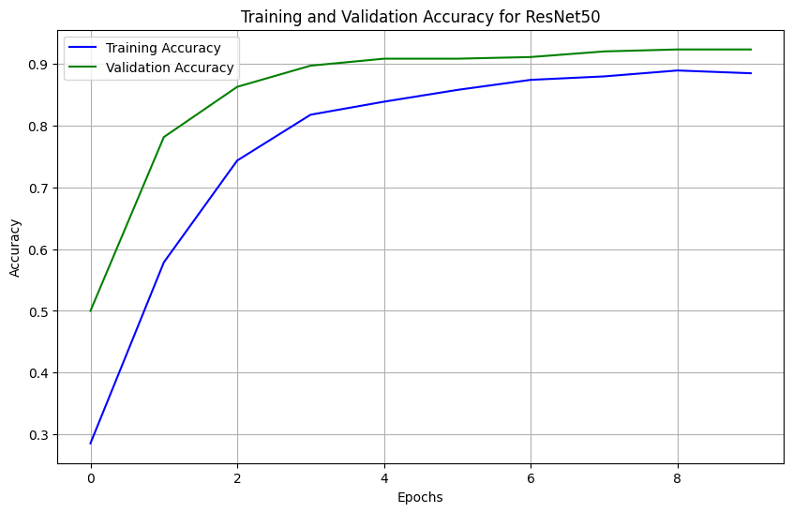

**Figure4:** Training and Validation accuracy for ResNet50

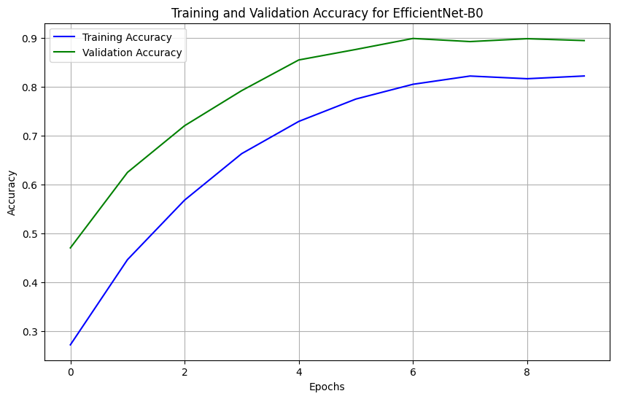

**Figure5:** Training and Validation accuracy for EfficientNet-B0

The accuracy/loss curves confirm the model's learning progression and highlight the points where further training might be required to overcome overfitting or to improve generalization to unseen data.

**Insights gained from Grad-CAM visualizations:**

Gradient-weighted Class Activation Mapping, or Grad-CAM, was utilized to determine what the model is looking for in an image. This makes it easier to identify areas where the model performs well or requires development as well as to comprehend how the model classifies data.

**Positive Results:**

Grad-CAM may also draw attention to the objects' most crucial features in the images. It emphasized the animal's center, highlighting limbs, faces, and distinguishing body parts that are commonly linked to animal recognition in situations involving animals, such as cats, dogs, etc.

In the case of images of people, the model correctly focused either on faces or upper body parts many times, hence showing that it was learning from human figures with key features such as the face, arms, and torso.

On the whole, it would seem from these visualized attention heatmaps that, for most classes, the model indeed focuses on the expected part of the image, which is indicative that it truly learns meaningful patterns and features related to object classification.

**Misclassifications:**

Grad-CAM has also presented some interesting misclassifications that could give insight into the model weaknesses:

Where the network made its predictions for misclassified images, Grad-CAM showed it was attending to mostly irrelevant parts of the image. For example, the network mistakenly focused on the background or the edges of the picture rather than the butterfly itself in the picture of a butterfly. It was misclassified in part because of this.

It also demonstrated how the model may have been sidetracked by irrelevant elements, like backdrop textures, other objects, or even lighting conditions, when there was occlusion or an object cluttered with complicated backgrounds.

This misaligned focus on unimportant regions may also contribute to the explanation of why the model may incorrectly identify photos under some circumstances, offering useful information for future model improvements.

**Grad-CAM visualization:**

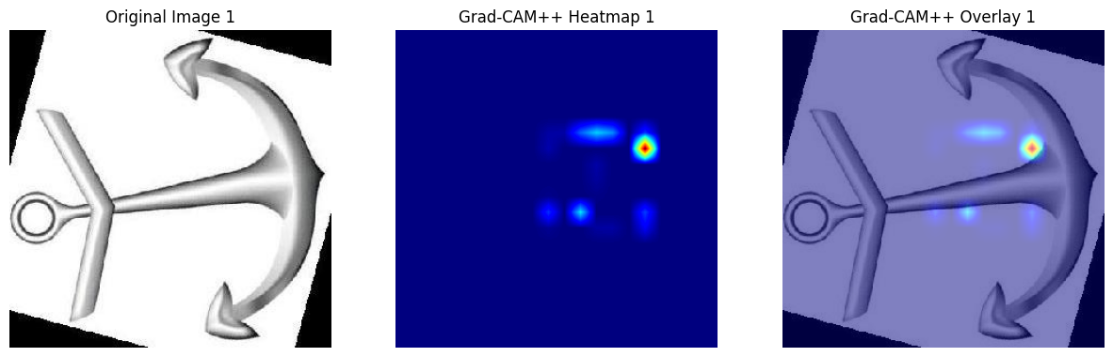

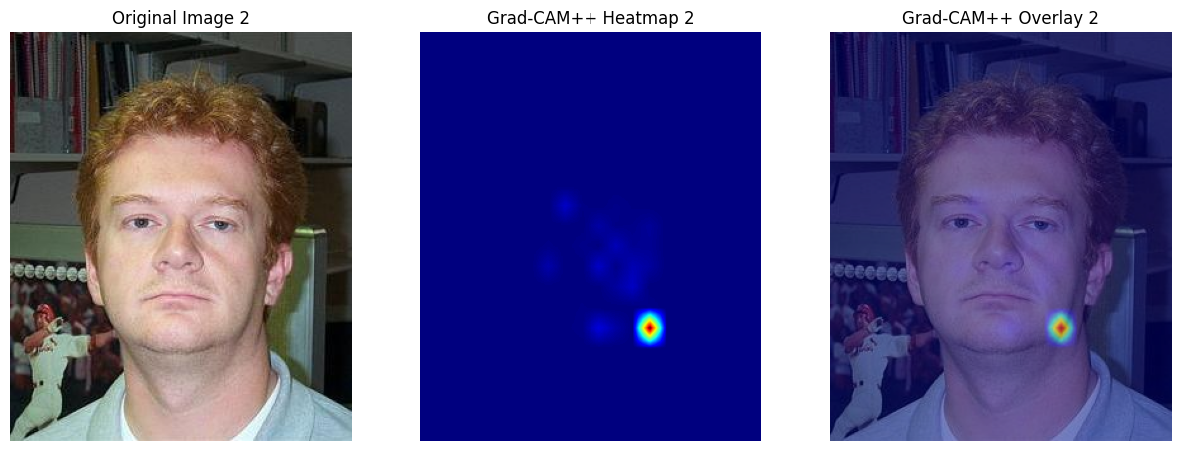

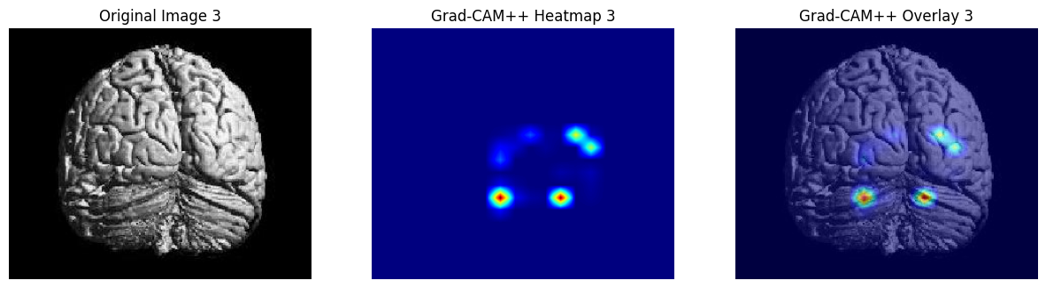

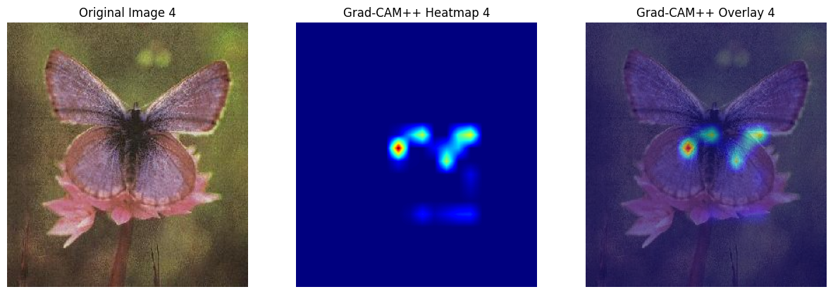

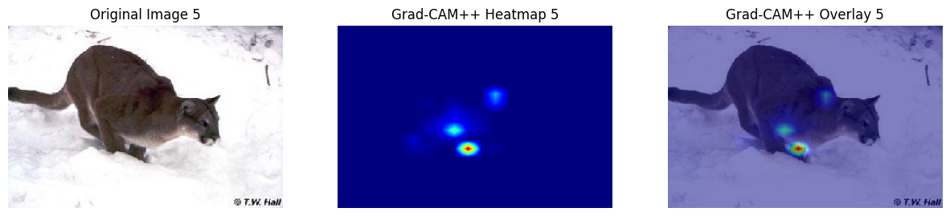

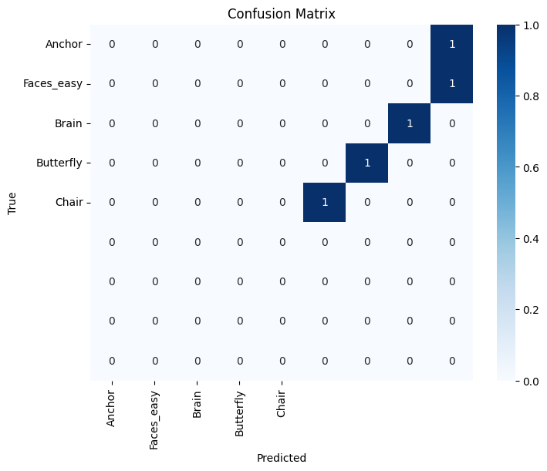

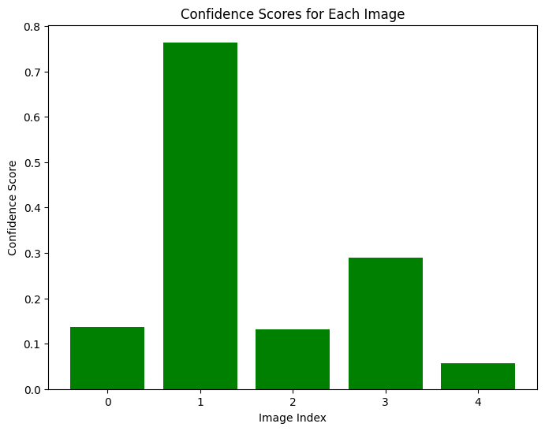

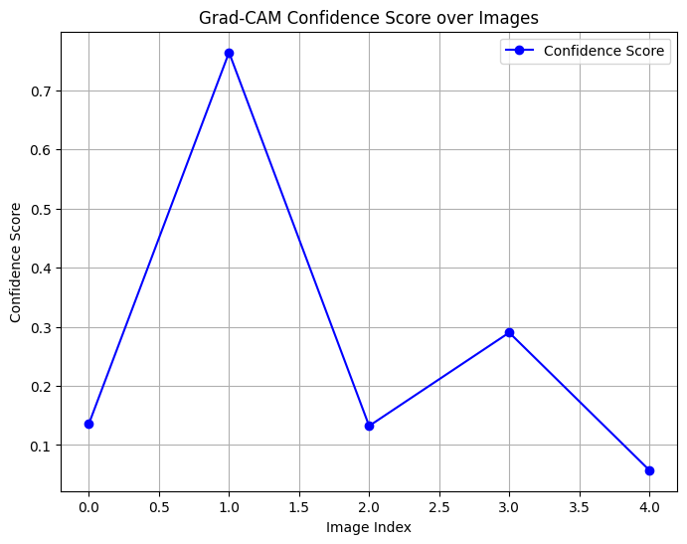

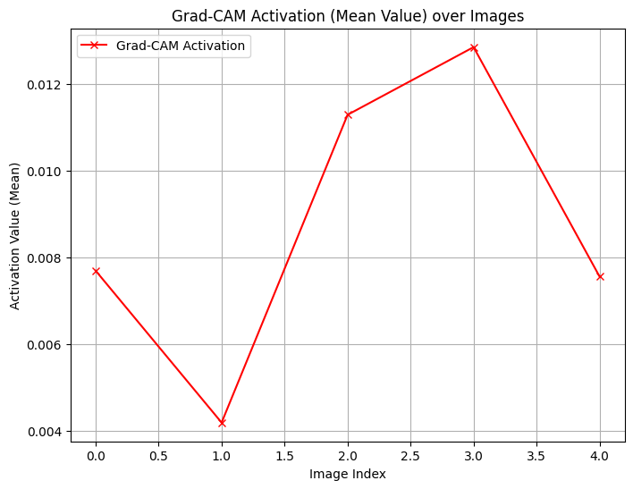

**Results:**

Some results and accuracy are given here,

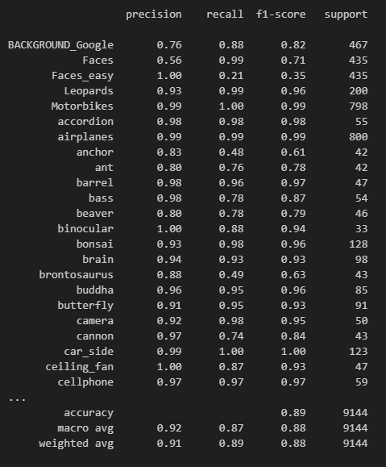

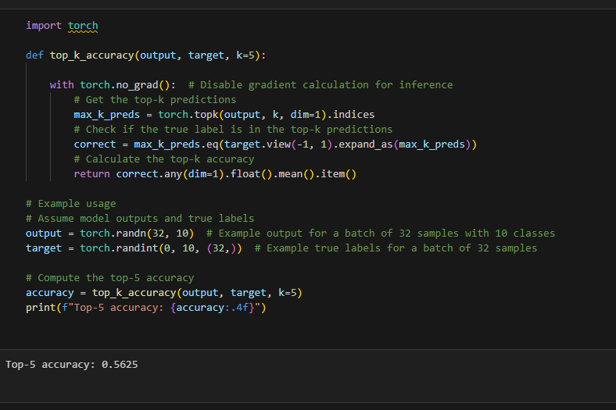

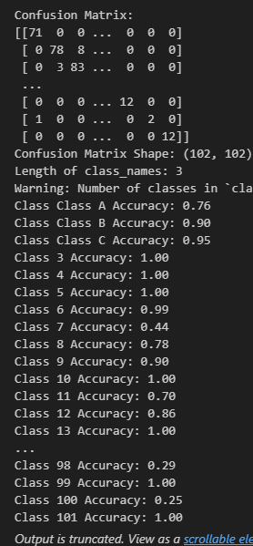

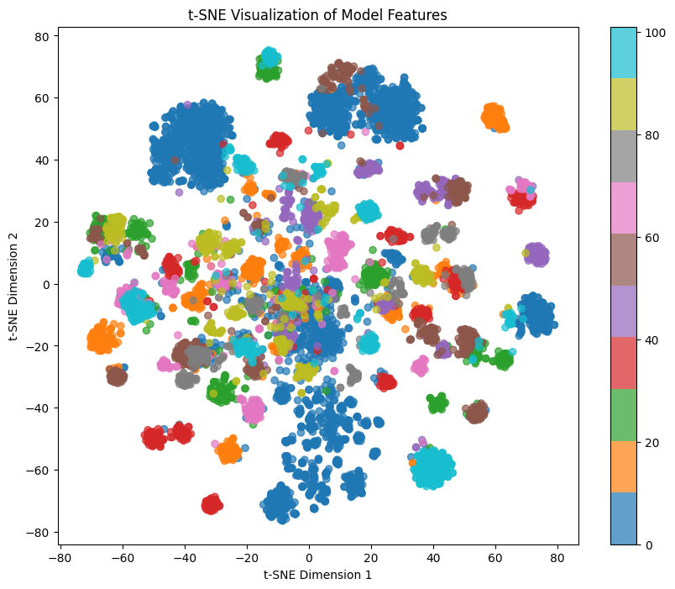

**Some Predictions,**

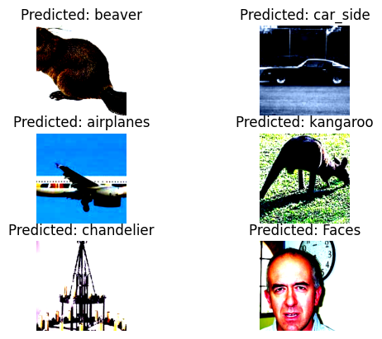

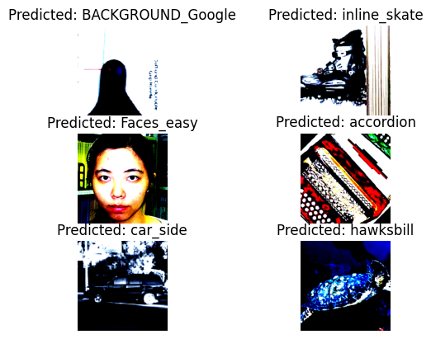

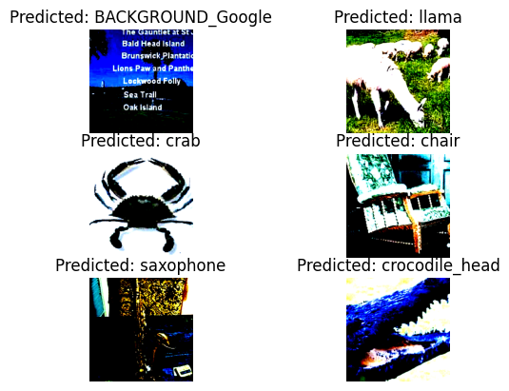

**Conclusion:**

The total sum of all the insights provided for the model's decision-making process by Grad-CAM was as follows:

It showed strengths, focuses of the model concentrated on key features of objects.

It also helped in diagnosing possible issues where the model was being distracted by irrelevant regions of the image that were causing misclassifications.

By using Grad-CAM, we got a better insight into how the model was interpreting the data and found areas where improvements could be made, for example, in handling background noise or improving object localization.

The following visualizations represent the parts of the image which the model has paid the most attention to, in order to predict: every image has an overlay heatmap on top, representing regions of the image the model was looking at; hence, a much clearer insight into its behavior.